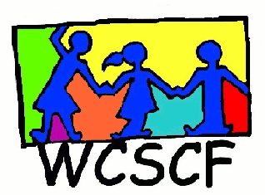
Northern Suburbs Street Children’s Meeting
11 October 2018
9:00 – 12:00
Uitsig NG Kerk, Ridgeworth
__________________________________________________________________________________
Present: Diana Berends (Badisa Kraaifontein), Vanessa Brink (Badiso Trio Bellville), Evelyn Le Roux (Badiso Trio Bellville), Charne Plaatjies (Badiso Trio Bellville), Riverne Walker (Badiso Trio Bellville), Wendy Bosse (Olympians), Roxanne Langley (Badiso Trio Scottsdene), Colleen Brookes-Gain (WCSCF) and Janice King (WCSCF)
Apologies: Nick Van Rooyen (Teahmo),

- Welcome and introductions. Janice welcomed those present. Everyone knew each other so no introductions were necessary.

- Next meeting: 2019

Enquiries: Janice King (Director)
Cell: 072 4500 456
Email: wcstreetchild@gmail.com

