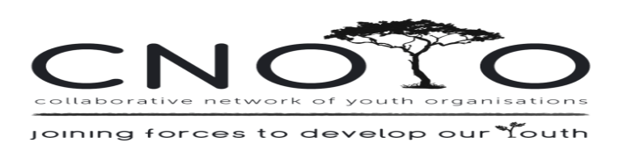
YOUTH DEVELOPMENT FORUM
ZOOM MEETING MINUTES
26th November 2020
10:00-12:30
_________________________________________________________________________________________
PRESENT: Allan van der Meulen (Zlto), Lorraine Karelse, Antonio Orison (Masithembele Enrichment Centre), Carry Ives (Living Hope), Tanika Thomas (Youth Outreach), Janice King (WCSCF), Colleen Brookes-Gain (WCSCF),

APOLOGIES:

- Welcome & Introductions.
Janice welcomed everyone. Introductions went around the room and thereafter our Guest Speaker was introduced.

- Guest Speaker:
Allan van der Meulen from ZLTO Currency and System
  - Zlto is a web-based app that can be accessed by any phone or electronic device. https://www.zlto.co/. Any organization can set up their unique webpage on the app to keep track of users and their progress. Users can upload anything to the app: tasks, volunteer hours, photos of them in action, and more.
  - Organizational registration costs R30 per user per month.
  - There’s no strict age limit on using the platform, however, if you are under 18 (depending on the job) you will need a guardian’s permission. There may be age limitations from organizations depending on the job.

Why are young people struggling to find employment?
  - A large, overlooked problem is the finances. On average, it can cost about R1,500/month to actively find work.
    - Many families are relying on grants.
    - Lack of qualifications. Many people can’t finish education and training due to finances to provide for their families.

What is Zlto doing to help?
  - Encouraging and providing volunteer experiences to gain working skills
    - Partner with reviewers (chosen at random) to avoid corruption and keep others accountable
    - Many young people are learning multiple skills while volunteering (i.e., time management, communication, etc.).
  - Teaching young people to spend their Zlto “rewards” on the platform wisely and weighing the comparative costs (i.e., paying for electricity, food, etc.).
    - Many young people choose to buy the necessary items or choose to volunteer more for more work experience and rewards.
  - The difference between Zlto and other great programs that help youth-workers is that Zlto gives rewards to those who volunteer/attend workshops so that they can provide for their household while gaining skills.
  - To motivate active participation, workshop attendees will have to reflect and write up to 500 characters to communicate with others what they’ve learned.

In the background, Zlto creates a digital CV that keeps track of all the work experience they have accumulated.
Zlto allows organizations to create mini-courses online for young job-seekers to further grow skills and education.
Users will upload an organization to their own account. Using a unique link, organizations can add users to their account.
Allan used screen share to show the Masithembele Enrichment Centre how to set up an organizational account on Zlto.

- Action Steps
Each organization represented can register as a partner on Zlto. Then they can share this opportunity with their clients and begin setting up tasks. Work with the Zlto administration team to set up specifics for their account.
WCSCF (Western Cape Street Children’s Forum) will set their account on Zlto as the umbrella organization.

Contact Details:
Allan van der Meulen
084 454 0702
allan@zlto.co

- Next meeting: TBA in 2021

