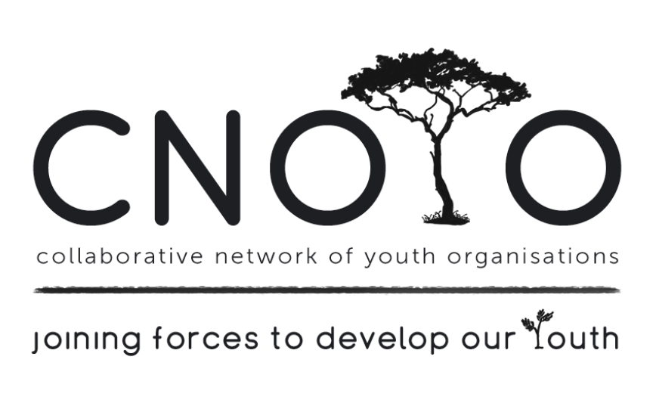
YOUTH DEVELOPMENT FORUM MEETING MINUTES
28th February 2018
Salesians Institute 9:30-12:00

PRESENT: Christopher Louw (HARAMBEE), Aarief Samodien (HARAMBEE), Kurt Linnet (Salesians), Sally Nascimento (Catalyx), Candice Amon (Life Choices), Melinda Bechus (), Vuyokazi Magobiyane (Private), Zubaida Hattas (Sowilo), Ayesha Davids (Sowilo), Zara (Life Choices), Sumaiya Davids (Sowilo), Anthony Baatjies (Gold-Youth), Veronica Geduld (VRCID), Jacque Pietersen (VRCID), Colleen Brookes-Gain (WCSCF)

APOLOGIES: Janice King (WCSCF), Cheryl Harper (We Can Change Our World)

- WELCOME & INTRODUCTION: Colleen welcomed everyone and introductions went around the room. Each delegate gave a brief description of their organization. The history and purpose of CNOYO was clarified.
It was decided by those present that:
- The Youth forum would meet every month (instead of every second month as done the previous year).
- Consistent attendance would increase the goal of support and growth.
- Local community Libraries would be used for meeting venues.
- Time for Q & A would be allowed after each Presentation.

- MEETING TOPIC: Employment Readiness, Skills and Training
Guest Speakers: HARAMBEE: Christopher Louw
CATALYX CONSULTING: Sally Nascimento
SALESIANS YOUTH: Kurt Linnet
YES Project (Youth Employment Skills): Andile Nkandidika
___________________________________________

HARAMBEE is a not-for-profit social enterprise with extensive experience building solutions and innovations that can solve the global youth unemployment challenge. Website: harambee.co.za
- not a recruitment agency but an employment readiness agency.
- work with young people aged 18-34years, must be a South African Citizen, and must have Grade 11; also have a platform for disabled young people who have Grade 9 and also be unemployed for about a year.
- partner with business, government, young people and many others who are committed to results that can work at scale.
- connect employers who are looking for entry-level talent to high-potential South African youth who are hungry for opportunity but lack the finances and networks needed to find jobs because they come from poor households. They tackle the youth unemployment challenge using data, innovation, partnerships and on-the-ground experience to build pragmatic, implementable solutions that get results.
- partnered with 400 employers from large corporates to SMEs
- helped over 47 000 young people find their first job.
- created job matches with over 1.5million assessments.
- do assessments, have mock interviews, anything to help make the transitions easier for them. They are then put forward to clients where clients make the selection and they continue working with those selected to ensure a smooth transition.
- exciting new development: currently rolling out the first leg of their mobi app - young people register to join their network and interact with HARAMBEE. They will be able to see how the system rates them.
Harambee has successfully proven that employers can benefit from a larger, richer talent pool and that youth from poor households with no prior work experience can perform in the job.

CATALYX CONSULTING designed and is managing this project for the MRP (Mr Price) Foundation. It’s a national project to assist non-profit organisations across the country that are training the unemployed to scale up their programmes, improve job readiness components, and place them into work experience and employment opportunities in the retail industry and other sectors. www.mrpfoundation.org
The project is funded jointly by the MRP Foundation and the Jobs Fund, a national government job creation initiative. Thirty training partners are participating across the country in certain provinces (Western Cape, Free State, Eastern Cape, Gauteng, KwaZulu Natal, Limpopo).
Criteria: Matric.
They - are mobile and go into communities to train. Wherever there’s a demand, they go.
- train their candidates for a week in Lifeskills, Job readiness training and focus on retail.
- have an agreement with Mr Price and Spar that they should take people off Catalyx database first before seeking staff elsewhere.
NB:
- A benefit of being permanently employed with Mr Price for a year, you get a 1000 shares - you are paid out twice a year…..over and above your salary.
- Staff can apply for study loans, paid back over time, but with every module you pass….Mr Price reimburses you.
- If you have been with Mr Price for 3 years and you have children, you can apply for a bursary for your child at a good school.
- Mr Price is BIG on seeing PROGRESS, and
- If you want to move to Durban, you can study further.

Built on Catalyx’s success with the Mr Price Jumpstart project, Catalyx has been requested to assist various companies and organisations with setting up their own similar projects, tapping into the Jobs Fund, National Skills Fund or other partnerships.
_________________________________________

YES PROJECT (YOUTH EMPLOYMENT SKILLS) - Andile Nkandidika Salesianyouth.org

Criteria: 18-26years. They run Courses aimed at giving young people the social and job skills they need to support themselves in today’s South Africa. Each Course starts with intensive group training in life skills, where they learn about personal development, the work environment and the social challenges facing the young people of today.

Students then select from a range of practical skills courses:
- Computer Literacy & Office Management (8-12 weeks)
- Computer Maintenance and Mobile Application Development (8-12 weeks)
- Bricklaying & Plastering (12-15 weeks)
- Food Preparation (12-15 weeks)
- Sewing (12-15 weeks)

Each course stresses hands-on learning, an ideal way to learn for many of these under-schooled youths. On graduation, students receive a certificate and ongoing help with job placement.
An Outreach program focuses on prisons, community based orgs and schools.
- Prisons: preparing the prisoners for pre-releasing by assisting them to make worthwhile positive connections for when they get out of prison. Aims to prevent them going back to joining up with gangs.
- Schools: Leadership programs with Gr 11-12 to prepare them for university or employment.
- Communities: working with orgs who need Life Skills Programs.
_________________________________________

SALESIAN YOUTH - Waves of Change (WOC) – Kurt Linnet
The fishing Industry in South Africa is a big part of the Western Cape’s economy. Salesians partners with some of the large fishing companies and train around 200 young adults each year, giving them an opportunity to work at sea.
- Assistance to young men and woman, between the ages of 18 and 30, that want to obtain training to prepare them for work at sea, gain employment in the fishing industry. Included is an intensive life skills program.
- They are throwing their nets wider to accommodate the broader maritime industry.
- They help their clients to obtain the necessary documentation with the assistance of their strategic partners, including: Safety Familiarisation Training, Seafarer’s Medical Examination, and a Seaman’s Record Book.
(Maritime registration and documentation with be international so every vessel on the ocean will have the same set of documentation.)
_________________________________________________

- DISCUSSION:
Do the Employment Readiness Agencies keep in contact with their candidates after completion of the course/ after job placement?
Yes - with both the client and the candidate and it was important and for keeping open doors. When in contact with the client it gives them an opportunity to know if the candidate is performing at optimum and if the client is happy with the candidate. Keeping in contact with the candidate gives them an opportunity to know whether the candidate is happy with the client, happy with the environment and if there are any hiccups. All this feedback serves to keep them apprised of situations to look out for etc.

CONCLUSION: The Employment Readiness Agencies recognise generally that when youth finish school or drop out, they are ‘clueless’ and ill equipped for the workplace. They have no sense of responsibility or work ethics nor do they know about time-management. They have unrealistic ideas of what it is to be employed. “Career Day” at schools are insufficient/ inadequate to realistically prepare youth for the workplace as it only occurs once a year and presents limited career opportunities.
- It was felt that WCED should be exposing youth to much more wrt to future careers/employment and have a more practical hands on approach.
- Looking at how other countries best practice models for getting their youth work ready should also be taken into account.
- Some high schools are more realistic and are working with employment readiness agencies. This catches youth before they fall through the cracks of society. Other schools seem completely oblivious. It would be great if it was mandated that High Schools link with Employment readiness agencies so youth can be exposed to the rights, responsibilities and opportunities of being employed. This would give them something to look forward to and plan towards.

4. NEEDS/ OPPORTUNITIES/ SUGGESTIONS:
- Could the Forum create a space of collaboration between the WCED and Employment Readiness Agencies?
- Anthony Baatjies (GOLD Youth) (anthony.baatjies@gmail.com) told the group of an NQF Level 6 programme, called Extended Education Practitioner Training Programme. WCED is in partnership with the University of Stellenbosch, Community Chest and RUTGERS. It is an 18 months studying programme, where you get educated on how to improve the after school programme like Peer Educations, Arts and Cultural and Sports.
- There is also the peer 2 peer programme which is a 8 months programme that WCED is running in some of their schools in all the Western Cape district's. The programme is a peer education programme that was developed by the organisation working for GOLD-YOUTH. But WCED is calling it the Care and Support Assessment CSA.
- Candice Amon @ Life Choices Academy
- They are offering a 6 month coding course (full time) plus a 6 month paid internship.
- You can apply online at www.lifechoices.co.za

7. Other Business:
Colleen to email the minutes to all present.
Creating a database of Employment Readiness Agencies and putting that info out in our FB Page.

8. Next meeting: 27th March 2018 Speaker: Ceasefire!

Enquiries: Janice King (WCSCF Director) Cell: 072 4500 456
Email: wcstreetchild@gmail.com

