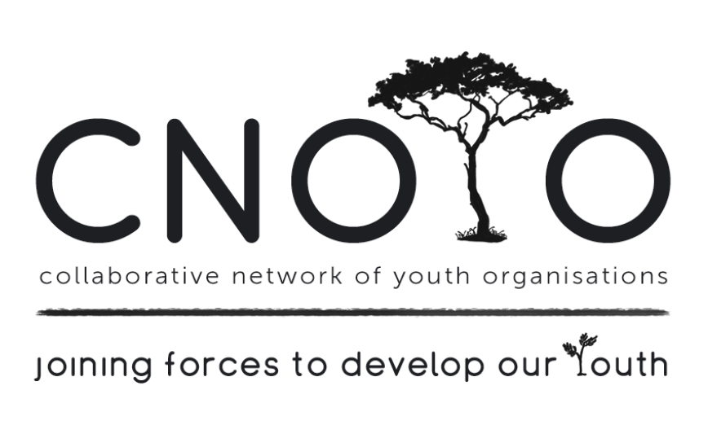
YOUTH FORUM MEETING MINUTES
27TH MARCH 2018
TOWN CENTRE LIBRARY, MITCHELLS PLAIN
9:30-12:00

PRESENT: Cheryl Harper (We Can Change Our World), Robert Pietersen (VRCID), Angelo Simpson (VRCID EPWP), Craven Engel (FCRC/CEASEFIRE), Grizelle Jones (Catalyx), Candice Amon (Life Choices), Jacque Pietersen (VRCID), Jamie-Lee Adams (COAST), Caila Pietersen (VRCID), Colleen Brookes-Gain (WCSCF), Norma V.D. Merwe (VRCID EPWP).

APOLOGIES: Janice King (WCSCF), Christopher Louw (HARAMBEE), Aarief Samodien (HARAMBEE), Vuyokazi Magobiyane, Dean Ramjoomia, Sally Nascimento (Catalyx), Marissa Dane (SA-Yes)

- WELCOME & INTRODUCTION: Colleen welcomed everyone and introductions went around the room. Each delegate gave a brief description of their organisation.

- FEEDBACK.
The first meeting for the year focused on Youth Employment readiness, skills training and the challenges associated with finding employment. One of the challenges were that many youth were dropping out of school and were unskilled in how to conduct themselves in an interview, hold down a job, etc. Hence “Lifeskills” is an important focus of Employment Readiness Agencies skills training. It is also recognised that High Schools are not helping to make youth EMPLOYABLE (with one career day and limited career choices). It was suggested that CNOYO look at garnering a meeting to LINK WCED and Employment Readiness Agencies and Businesses (possible Internships). The aim is to offer youth a broader perspective wrt to future employment and not limit or demoralize them.

- MEETING TOPIC: Gang Involvement, Criminal records and the Impact on our Youth
Guest Speaker: Craven Engel - CeaseFire & FCRC, Hanover Park

POINTS TO PONDER:
- Currently there are 1000 youth languishing in Pollsmoor, doing nothing with their time, waiting on their Legal Aid lawyer who shows up on a Friday resulting in very few youth getting to see their lawyer. What could be done about these youth…some program was definitely called for.
- The problems of drugs and gangsterism coupled with high levels of poverty are related to the housing developments introduced as part of the Apartheid spatial planning model that followed the forced removals due to the Group Areas Act signed into law on 27 April 1950. This nefarious spatial planning model is still followed when new housing developments are created around Cape Town - with equally disastrous results.

HISTORY of CEASEFIRE. Originally founded in Illinois, USA in 1995 by Dr Gary Slutkin, CeaseFire takes a public health approach (many gangsters suffer from TB and HIV Aids) to fighting gun violence. It was brought to SA and the pilot was implemented in Hanover Park, under the leadership of Pastor Craven Engel from Hanover Park, who operates a church ministry that runs a number of outreach programs from 2nd floor, First Community Resource Centre.

After 2 years, it was evident that the same methodology employed in USA wasn’t working in Hanover Park. The people, circumstances and mindsets were different. With that in mind, Craven was given the opportunity to rewrite the program to suit the SA environment and specifically for Hanover Park. The idea was to recruit interrupters (former gang members) who serve as the antibiotic and outreach workers to act as a ‘curative’ - which also includes nurses and social workers. They arerecruited and trained to work only with high risk individuals. Interrupters” develop relationships over time with people considered at-risk for committing acts of violence. Through these relationships, the interrupters try to dissuade these would-be aggressors from turning to guns, and teach them how to solve conflicts in different ways. Outreach workers spend much of their time driving through Hanover Park, talking with gang members to establish the kind of social connections that will help them glean information about when or where conflicts are likely to arise. When an outburst is likely, the violence interrupters meet with local gang leaders, working to resolve conflict through nonviolent means and dissuade gangs from using violence as retaliation.

CeaseFire makes extensive use of technology in their drive to prevent gang violence from flaring up. Safety Lab has developed a system for CeaseFire to more efficiently and effectively capture data on evolving trends in gang violence in the area. This way the programme can better predict, and try to prevent, violence. This more efficient system has freed up field workers to focus on violence intervention and prevention work on the streets, rather than expending many hours culling through paper-based logistical work.
The program requires commitment from CeaseFire as relationships are based on trust and fieldworkers need to be available when called upon. The CeaseFire crew is always in danger, however they persist believing in their strategy. The work they do brings some hope to a community ravaged by gang violence, drugs and abject poverty, and no matter how little it may seem; they make a huge difference in the individual lives they influence. Though it is not a cure-all and many other interventions still need to take place before any major decrease in gang activity can be seen, there are talks about the CeaseFire program being adapted for other gang-infested communities across South Africa, bearing in mind the research takes a lot of time because no two communities are alike.

Gang involvement, Criminal Records and the impact on our youth
Youth veer towards drugs for a myriad reasons and one of those reasons are the lack of positive father figures in their formative years. The use of drugs and the inability to sustain it financially drives youth to joining gangs and fall into criminal acts such as muggings, theft, housebreaking and selling drugs for dealers. The result is that these youth eventually end up in jail for possession of drugs or for other criminal act. Once in jail, it’s rare that their case is heard immediately, and they sometimes languish in jail for months at a time but with nothing to look forward to. These youth might have been picked up for what is described as petty crime but while in jail they often learn the tricks of the criminal trade and by the time they are released they are halfway to becoming hardened criminals. Some, through intervention programs in their communities, resolve to kick the habit and turn their lives around. They get into a rehab program, they get the support structure necessary, they eventually get up-skilled, get their certificate and are eager to find employment. BUT… they have a criminal record and the chances of them finding employment becomes nil. This results in the youth becoming depressed, going back to drug usage and back onto the road that they had left. This sets the youth up for failure. Some are fortunate enough to get employed, despite their criminal record, but this is the exception to the rule.
Ceasefire works tirelessly to get the criminal records for first time petty crime offenders related to drug usage, expunged, but its slow going.
- The program has since been patented by Craven and running 6 years now. The programme relies solely on donations.
- Feel free to follow CeaseFire on FB and network with them.

FCRC, Craven Engels other NGO Programme, works wisely by offering a ‘wrap-around’ service.
- They feed 300 people per day - every day.
- They have a PC Centre for NEET Youth ( a young person “not in employment, education or training” - a young person who is no longer in the education system and who is not working or being trained for work), to connect them with Employment Readiness Agencies and partnering with businesses for possible job creation.
- They have a program called Character Company for ages 5-10yrs.

It’s a known fact that many children especially boys, grow up with an absent father. They see how their mom struggles to survive and they want to help. Many times gangs see this family set-up and exploit this young child, drawing him into the world of crime and repay him with money and goods eventually leading to drug use. The new trend is to use this very young child as a hit man. For that reason Ceasefire has a new program that targets little boys aged 6+ where they partner the child up with a positive male role model (pseudo father figure/ mentor), who interacts with them, takes them out and is interested in their wellbeing and welfare. With someone caring about them and their livelihood, they start to feel that they are important. It’s vital that the pattern of gang involvement be broken - one way is to catch and steer these youngsters away from the lure and influence of the gangs, by providing them with another option. This ‘wrap-around service’ is designed to catch these youth and young children.

- DISCUSSION
- Cheryl (We can change the World) offered to meet with Craven wrt linking CeaseFire to businesses and the 10 000 incarcerated youth.
- It was suggested that putting first offending youth into CYCC’s (eg Bosasa) can create gangsters. It was suggested that some CYCC’s could be run by the youth numbers gang, to the point that workers are threatened. (??)

7. Other Business. None

8. Next meeting: 25th April 2018 – Substance abuse and its impact on youth and their families
@ Delft Library, Voorbrug Rd, DELFT.

Enquiries: Janice King (WCSCF Coordinator) Cell: 072 4500 456
Email: wcstreetchild@gmail.com

